CONTACT:
Brice Lemasle
Hampton by Hilton Paris Saint-Ouen
cdged_hampton@hilton.com
Hampton by Hilton opens doors in Paris
in Saint-Ouen-Sur-Seine, France
New property located near North Paris,
les puces de Saint-Ouen and the Stade de France

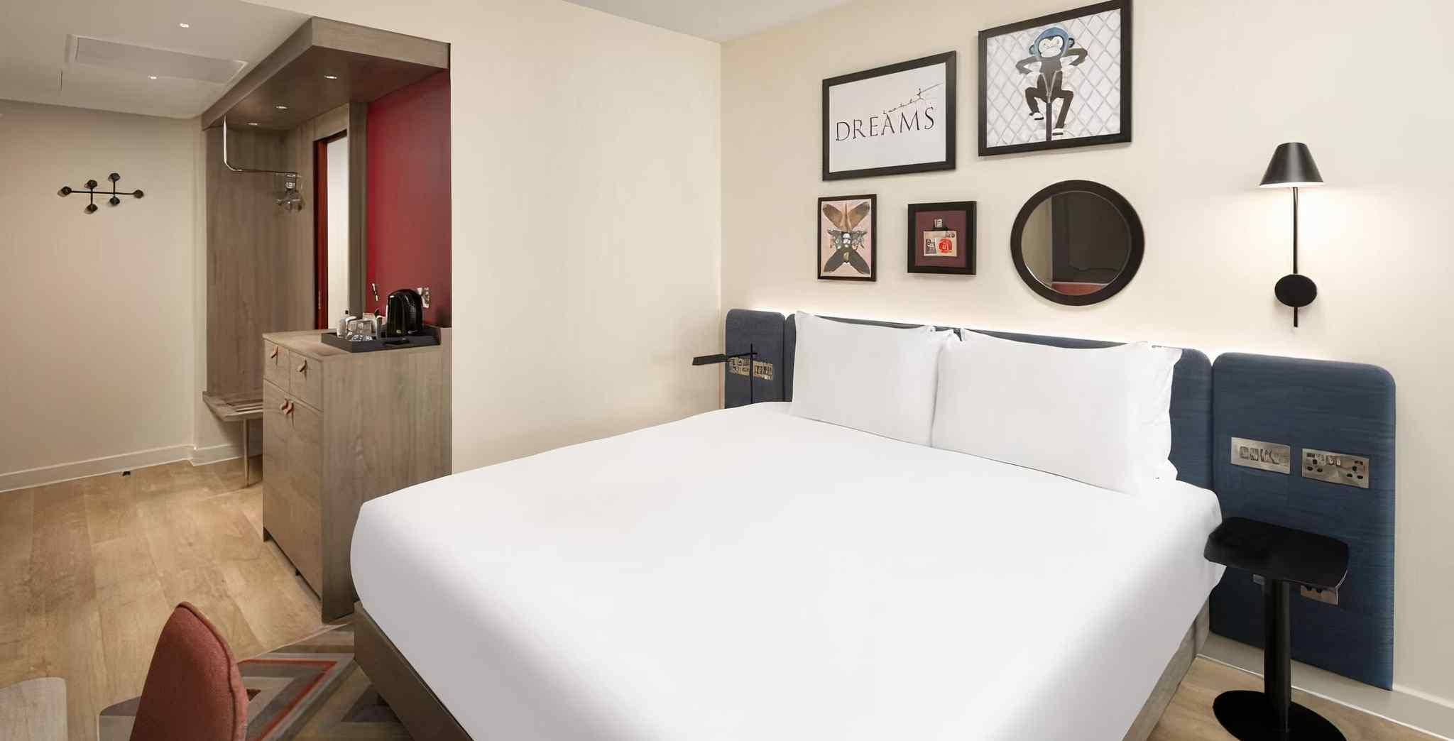
An eco-responsible hotel offering free hot breakfast, modern comfort and Hampton hospitality just minutes from central Paris

Saint-Ouen, Paris, France – 8th of June 2026 – Hampton by Hilton Paris Saint-Ouen, located near the northern attraction of Paris in the dynamic area, officially opened its doors today in Saint-Ouen Paris, France.

The property features 137 guest rooms, standard brand amenities including free hot breakfast, modern fitness center, snacks and drinks at our 24-hour treat shop, pet friendly hotel, free wi-fi and a bar. Each guestroom includes TV - 55 Inch Flat Panel HD, HDTV, and a coffeemaker.

“We are delighted to celebrate the opening of the Hampton by Hilton Paris Saint-Ouen, an exciting project for Hilton. We look forward to welcoming our first guests and sharing the warm, friendly hospitality that defines the Hampton by Hilton experience,” said Brice Lemasle, general manager.

Hampton by Hilton Saint-Ouen offers the ideal balance between business efficiency and discovering Paris. Located in Saint-Ouen, just outside the city center, the hotel provides easy access by public transportation to the main business districts in Paris, as well as to major attractions, shopping areas, and cultural landmarks.

Business travelers benefit from modern, comfortable guest rooms featuring ergonomic workspaces, making the hotel well suited for project-based stays and frequent travel. Covered parking is available nearby for guests arriving by car. Leisure guests enjoy a convenient base for exploring the city, along with rooms designed for comfort and relaxation after a full day of sightseeing, making the hotel an ideal choice for individual travelers, corporate teams, couples, friends, and families alike.

Nightly room rates start from 99 euros with fully flexible booking options and free changes or cancellations up to 24 hours before arrival.

Hampton by Hilton Paris Saint-Ouen is also part of Hilton Honors, the award-winning guest loyalty program for Hilton's 26 world-class brands. Members who book directly have access to instant benefits, including a flexible payment slider that allows members to choose nearly any combination of Points and money to book a stay, an exclusive member discount, free standard Wi-Fi and the Hilton Honors mobile app. Book direct at Hilton.com, through the Hilton Honors app or through other official Hilton channels for more perks and a price match guarantee. Hilton Honors members can redeem Points using the Points Explorer tool.
Hampton by Hilton Paris Saint-Ouen is located at 1 rue Rosa Parks in Saint-Ouen-sur-Seine.
For more information, or to make a reservation, travelers may visit https://www.hilton.com/en/hotels/cdgedhx-hampton-paris-saint-ouen/
call +33 (0)1 89 89 01 01.

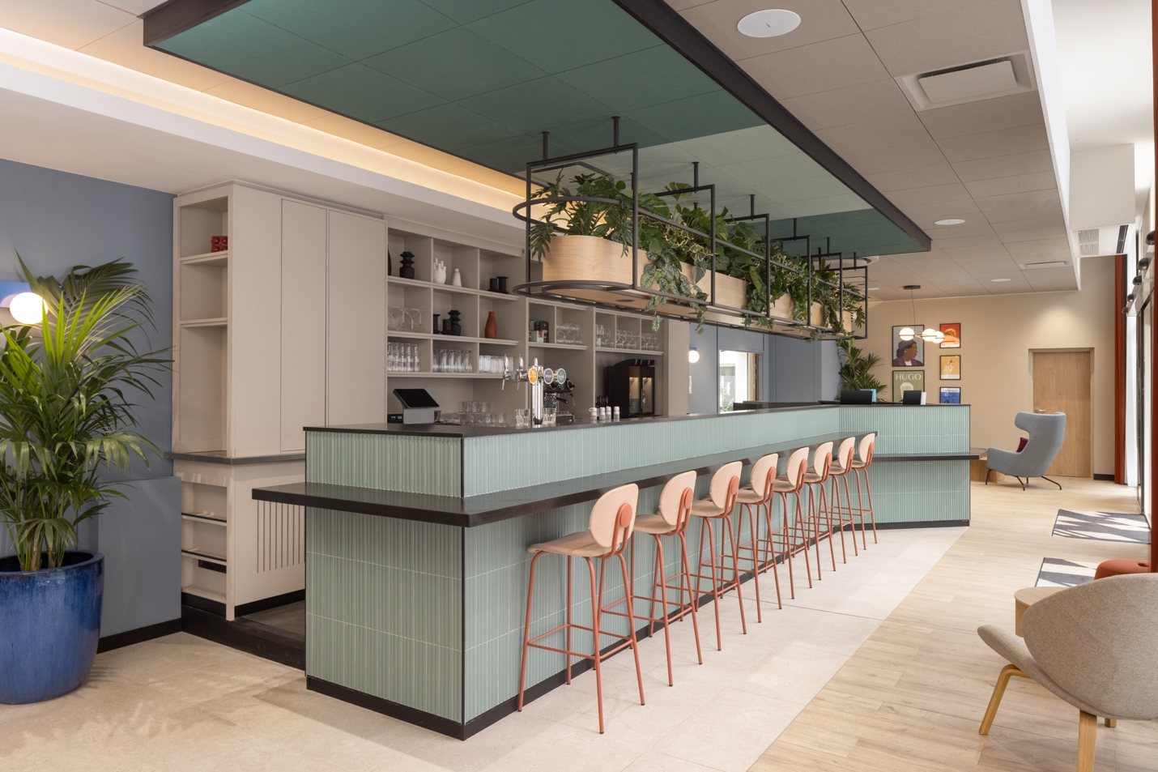
Link to download photos

The property is owned and managed by Central 1928.
For more information, please visit https://hotels-bourgogne.com/

# # #
About Hampton by Hilton
As the No. 1 ranked lodging franchise for the last 17 years by Entrepreneur®, Hampton by Hilton — including Hampton Inn by Hilton and Hampton Inn & Suites by Hilton — serves quality-driven and value-conscious travelers at more than 3,100 properties in 46 countries and territories around the globe. The brand continues to lead its segment by providing guests with high quality, thoughtfully designed accommodations and amenities, such as modern, spacious rooms and free hot breakfast featuring the signature Hampton Waffle. Hampton by Hilton is committed to delivering an exceptionally friendly and authentic service, all backed by the 100% Hampton Guarantee™. Experience a best-in-class stay at Hampton by Hilton by booking at hampton.com or through the industry-leading Hilton Honors app. Hilton Honors members who book directly through preferred Hilton channels have access to instant benefits. Learn more about Hampton by Hilton at stories.hilton.com/hampton, and follow the brand on Facebook, Instagram and X.

About Central 1928
Central 1928 is a Burgundy-based group established in Paris, specializing in hospitality and dining for five generations. Drawing on this expertise, it focuses on the quality of its welcome and its teams to offer comfort and modernity with complete peace of mind. The group’s solidity enables it to constantly innovate, responding to the latest trends and new lifestyles for the well-being of its guests, while respecting the environment.

